Dear Davi,

Randle here again, it was lovely chatting to you earlier.

To summarize our conversation, you engaged with the CloudFront team, as your internal team released a new SCP policy that denied you the ability to change your s3 bucket origin to allow public access.

Thus, we jumped on a chime call to dive deeper into your issue,

While on the chime call, we first discussed distribution ID "E18HASOWNFEMT5", upon reviewing the RID you provided for the 502 error "6CtxK7PM33wcf5tUROCArhnwFW35QRPqsCMYZ0B7Gg7kcqAWjlYkVg==" , I managed to retrieve the internal logs for the 502 errored request, upon reviewing the internal logs, I advised you that the request is failing due to the TLS handshake failing between CloudFront and your origin, upon a further deep dive we identified that the SSL certificate on your ALB named "ALB-digital-institucional-uat" has expired, I did show you this while you were in the ELB console. Thus I explained once you renew or add a new certificate to your origin, the 502 error will be resolved.

Moving to the core issue that you raised, we identified that previously you had s3 origin configured with the website endpoint in CloudFront,
- thus I went on to explain that when working with S3 from a CloudFront perspective you have two different endpoints for each bucket:
  - one endpoint being the website endpoint - I explained that if you configure CloudFront with the s3 website endpoint, you would need to make the bucket public
  - the other endpoint being the API endpoint - If you however configure your CloudFront distribution with the s3 API endpoint, then you would need to configure OAC/OAI[1] in CloudFront for your bucket, so that CloudFront can authenticate and securely request data from your s3 origin.
- Due to the new SCP policy implemented in your origin using the website endpoint would not work, as the policy prevents any user from making a bucket public, and as discussed above for the website endpoint you would need to make the bucket public.
- Thus to resolve your issue, you would now need to add the API endpoint of the s3 bucket to CloudFront under origin.

Thus we performed the following actions to have this configured:
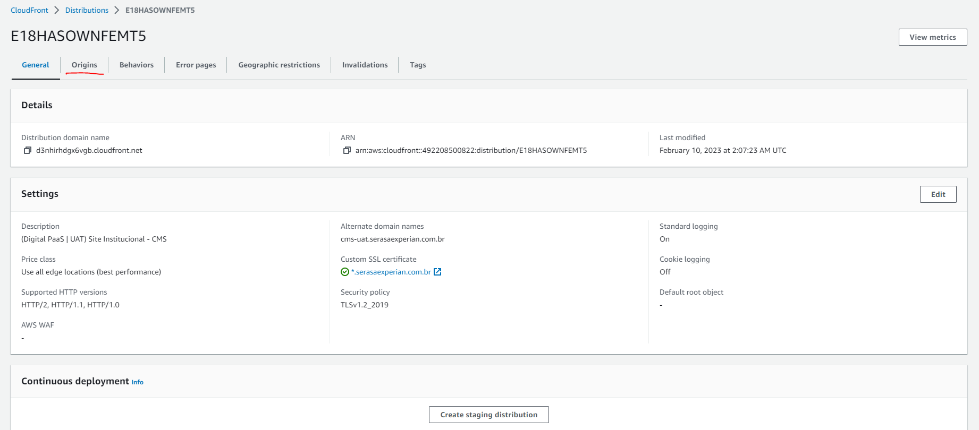
1) We create a new origin, where we selected the s3 bucket from the drop-down list. We then configured origin access control for the bucket, this in turn provided us an s3 bucket policy that we then used on the s3 bucket, basically we copied the policy, navigated to the s3 bucket in the s3 console, and then added the policy to the bucket.
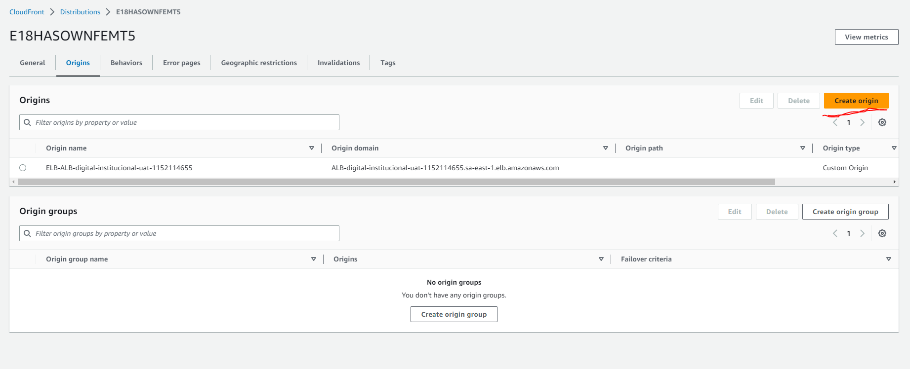

2) Once the origin was created, we then needed to assign it to a behavior, as I explained initially you would need to create and assign origin to every behavior that currently utilizes an s3 website endpoint origin. Thus in your example the default behavior utilized a s3 bucket with the website endpoint, thus we edited the default behavior and from the drop down menu for "Origin and origin groups" we selected the new s3 api endpoint origin we created in the first step

3) We then allowed the distribution to deploy and then performed an invalidation[2] to remove all odd data from cache using the path pattern /*. Once the distribution deployed and the invalidation completed we then tested and found that the issue was resolved, I did however explain to you that moving forward you would need to utilize the full path to the s3 object, as now since you are using the s3 api endpoint, the index.html file will not automatically load, thus you will need to make the request to the full path "www.example.com/index.html".

I do believe you will be performing the above steps in your dev environment before applying it to your production environment, thus I did explain that if you are having an issues with following the above steps, please do let me know and we can jump on a call and I can walk you through the steps again and implement it in your prod environment, my office hours are from 7AM UTC - 4PM UTC, therefore please do let know and we can schedule a call at the desired time you would like to do the changes on your production environment, you can respond over the email/web correspondence and that should come directly to me. If however my office hours falls out of your availability you can always open a chat or call and the next available engineer can jump onto the call with you to assist.

I hope the information discussed has provided clarity and I would like to thank you for affording me the opportunity to assist you, if you require further assistance please do not hesitate to reach out to me as I am always happy to assist

References:
=========================
[1]https://docs.aws.amazon.com/AmazonCloudFront/latest/DeveloperGuide/private-content-restricting-access-to-s3.html
[2]https://docs.aws.amazon.com/AmazonCloudFront/latest/DeveloperGuide//Invalidation.html

We value your feedback. Please share your experience by rating this and other correspondences in the AWS Support Center. You can rate a correspondence by selecting the stars in the top right corner of the correspondence.

Best regards,
Randle V.
Amazon Web Services
===============================================================

